
Ras (A146V)
Catalog Number: CR-M26479
Gene Symbol: H-Ras; K-Ras; N-Ras
Description: Anti-RAS (A146V) Mouse Monoclonal Antibody

Background: The A146V mutation ofKRas
results in an amino acid substitution at position
146, from an alanine to a threonine. KRAS
encodes a protein that is a member of the small
GTPase superfamily. Ras A146V mutation results in decreased GTPase activity and constitutive
signaling. It can be found in many tumors, such as lung adenocarcinoma, mucinous adenoma,
ductal carcinoma of the pancreas and colorectal carcinoma .
Immunogen: A synthetic peptide from the internal region of Ras which includes the mutation of A146V, human origin.
Tested applications: ELISA, WB, IF, IHC Recommended dilutions:
ELISA: 1:1000-1:5000
WB: 1:500-1:1000
IF: 1:50-1:1000
IHC: 1:25-1:100
Concentration: 1 mg/ml
Host: Mouse
Clonality: Monoclonal
Purity: Purified from ascites
Format: Liquid Storage buffer:
Preservative: no
Constituents: PBS (without Mg2+ and Ca2+), pH 7.4, 150 mM NaCl, 50% glycerol
Species Reactivity: Recognizes A146V mutant, but not wild-type RAS of vertebrates.
Storage Conditions: Store at -20°C. Avoid freeze / thaw cycles.

Western blot:
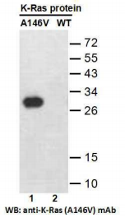
Western blot analysis of recombinant Ras (A146V) and wild-type proteins.
Purified His-tagged Ras (A146V) protein (lane 1) and corresponding wild-type protein (lane 2)
were blotted with anti-Ras (A146V) monoclonal antibody (Cat. #26479).

For research use only. Not for diagnostic or therapeutic applications.

Immunofluorescence:
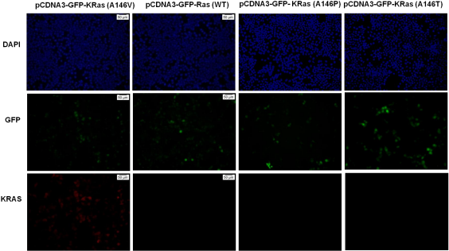
Immunofluorescence of cells expressing KRas proteins with anti-KRas (A146V) antibody.
HEK293T cells were transfected with pCDNA3-GFP-KRas (A146V) plasmid, pCDNA3-GFP-KRas
(WT) plasmid, pCDNA3-GFP-KRas (A146P) plasmid or pCDNA3-GFP-KRas (A146T) plasmid, then fixed and stained with anti-KRas (A146V) monoclonal antibody (Cat. #26479).

科博瑞（武汉）生物科技有限公司
TEL：027-87615885 15972062685
- mail：3636901710@qq.com
Web:www.coburybio.com

